SMS authentication in Pega

Steps

* Create account in Twilio
* Then buy a number with given credits
* Then capture your SID and Token from console

Now after doing all these things

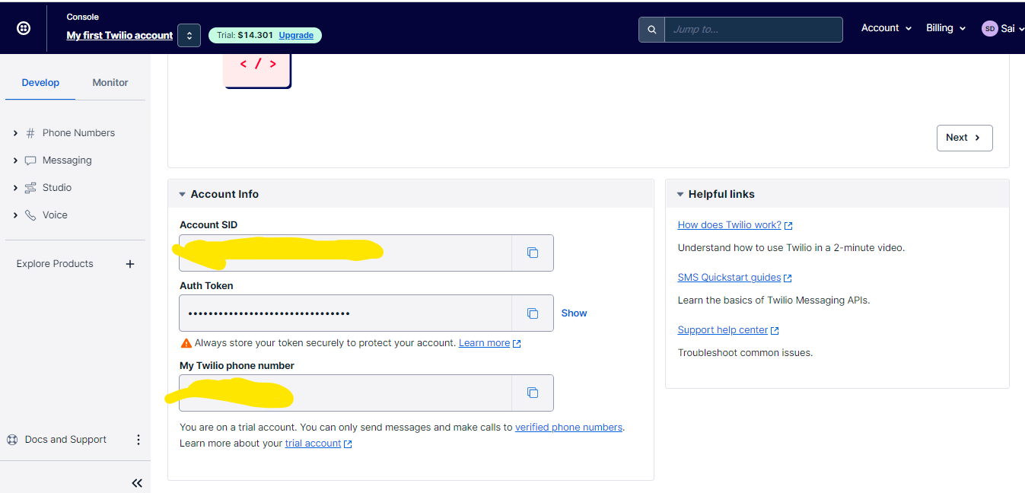

Create one rest integration and activity

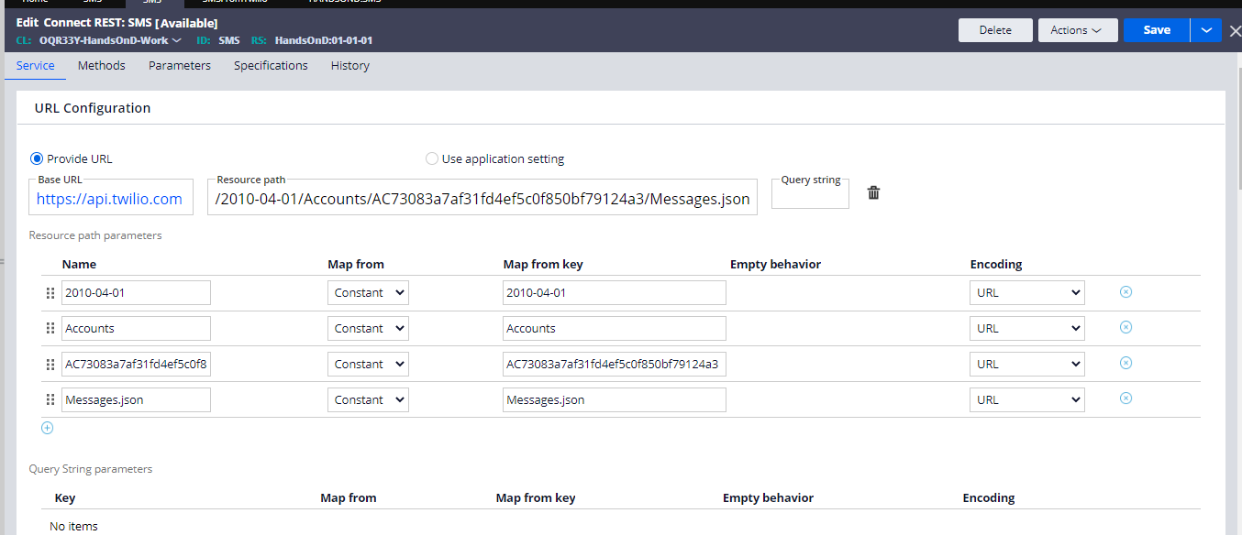

And the API is like the below

<https://api.twilio.com/2010-04-01/Accounts/.Request.AccountID/Messages.json>

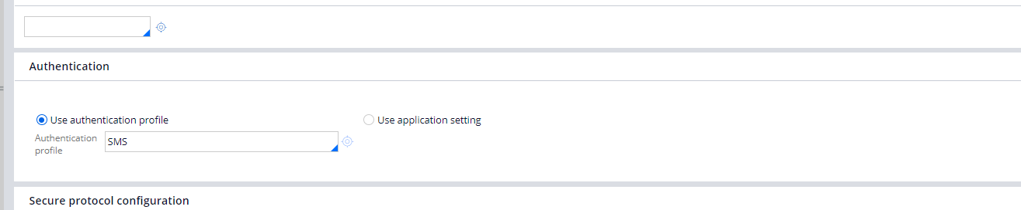

Give the authentication by creating it from security > authentication profile

Choose basic authentication

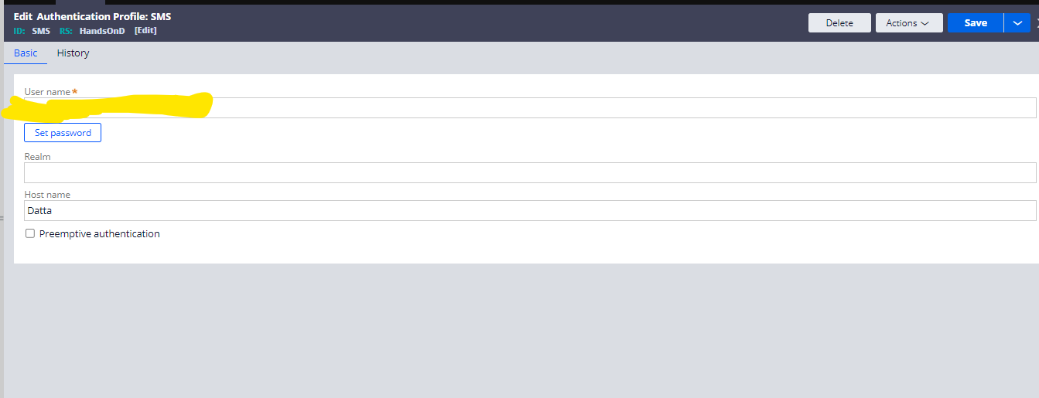

Give your SID and token in the profile and save and use this in the connector

Now in the methods use the message data by giving from number and to number and body I am using constant values we can use the clipboard mapping if created from the wizard.

For now I am using constant giving my number and then giving the body

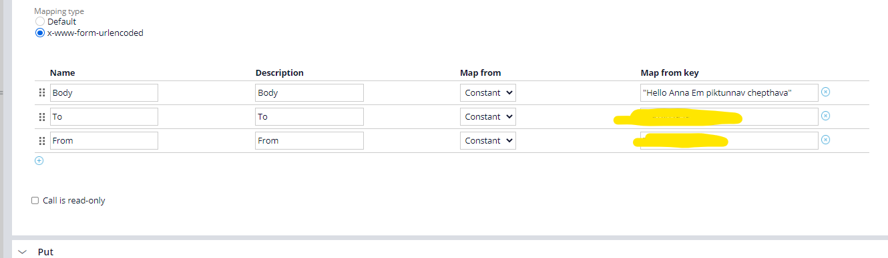

And then use the activity to invoke the connector and run and get the result

Can configure as below

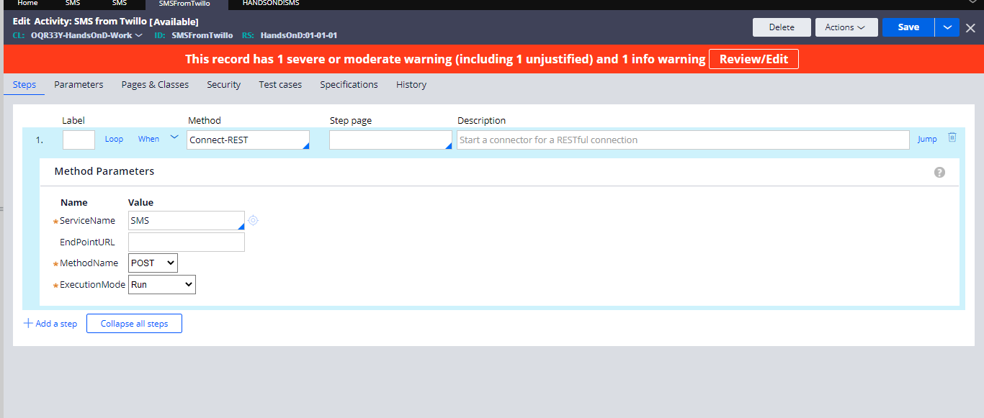

And now you can receive a message.

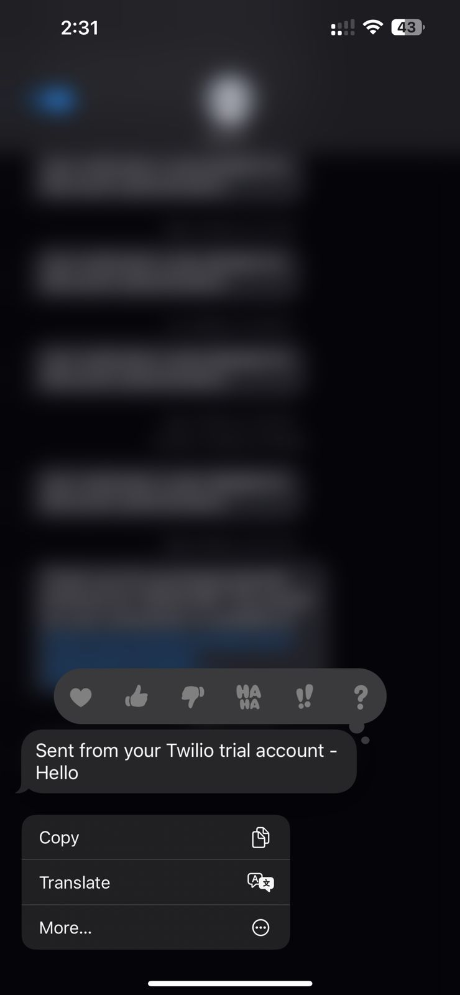

And hence the SMS is received

**NOTE- THE RECIEVER NUMBER SHOULD BE REGISTERED IN TWILIO TO RECEIVE MESSAGES**